**PERCEPTRON-XFMS-XFMS** *V 1.0.0.0*

A Web Server for X-ray Foot Printing with Mass Spectrometry (XFMS) Data Analysis

**USER MANUAL**

**Biomedical Informatics and Engineering Research Laboratory,**

**Department of Life Sciences,**

**Lahore University of Management Sciences,**

**Pakistan.**

biolabs.lums.edu.pk/BIRL

*Last Modified: 19-03-2025*

# Table of Contents

Table of Contents 2

1. Requirements for in-house Deployment 3

1.1. Hardware Requirements 3

1.2. Software Requirements 3

1.3. Testing the Deployment 3

2. Step-by-Step Guide to in-house Deployment 4

2.1 Installing Visual Studio Code (VS Code) 4

2.2 Installing SQL Server Management Studio (SSMS) 6

2.3 Installing Node.js.8.11.1 7

2.4 Installing SQL 2017 9

2.5 Installing Angular 1.7.4 10

2.6 Adding PERCEPTRON-XFMS-XFMS Database using SQL File 12

2.7 Download MATLAB 13

2.8 Download R 14

2.9 Download Frustratometer 15

2.10 Bridge2 Environment 16

3. Building PERCEPTRON-XFMS-XFMS for in-house Deployment 18

3.1 Downloading PERCEPTRON-XFMS 18

3.2 PERCEPTRON-XFMS Calculation Pipeline 19

3.3 PERCEPTRON-XFMS Application Programming Interface (API) 19

3.4 PERCEPTRON-XFMS Front-End 22

3.5 Connecting PERCEPTRON-XFMS API to PERCEPTRON-XFMS Front-End 22

3.6 PERCEPTRON-XFMS Simulation Service 23

# Requirements for in-house Deployment



## Hardware Requirements

For in-house deployment of PERCEPTRON-XFMS-XFMS, the hardware requirement includes a minimum of 5 GB of available disk space. is required.

## Software Requirements

Compilation and software build of PERCEPTRON-XFMS requires the following software:

* Windows 10
* Visual Studio 2017
* Angular 1.7.4
* Node.js 8.11.1
* SQL Server Management Studio (17.6 or 17.9.1)
* .NET Framework 4.8
* MATLAB 2021b
* R 4.2.2.
* Python 3.10

## Testing the Deployment

The freely available public deployment of PERCEPTRON-XFMS is hosted on a Dell Power Edge R730, 2 x Intel Xeon E5-2620, 160 GB RAM (16GBx10). The following Windows versions are compatible with PERCEPTRON-XFMS:

* Windows 10
* Win Server 2012 R2

# Step-by-Step Guide to in-house Deployment

## Installing Visual Studio Code (VS Code)

Users can download VS Code setup using the following link:

<https://code.visualstudio.com/download>

Click **‘64 bit’** in front of **User Installer** to download the setup. Run the downloaded .exe file.



Accept license terms and choose a destination folder to download Visual Studio Code setup.



Click **‘Next’** then select **‘Add to PATH.’** Click **‘Next’** to proceed.



Click **‘Install’** to begin installation. Click **‘Finish’** to complete installation.



## Installing SQL Server Management Studio (SSMS)

Users can download SSMS setup (version 17.6 or version 17.9.1) using the following link:

<https://docs.microsoft.com/en-us/sql/ssms/release-notes-ssms?view=sql-server-ver15#additional-downloads>

Click **‘Download’** to download the setup. Run the downloaded .exe file.



Click ‘**Install’** to begin installation. Click **‘Close’** to complete installation.



## Installing Node.js.8.11.1

Users can download the setup using the following link:

<http://www.npackd.org/p/org.nodejs.NodeJS64/8.11.1>

Click on **‘Download Node.js 64 bit 8.11.1’** to download node.js setup. Run the .exe file for installation.

Click **‘Next’** and accept license terms to proceed.





Click **‘Install’** to begin installation.



Click **‘Finish’** to complete installation.



## Installing SQL 2017

Users can download Structured Query Language (SQL) 2017 setup using the following link:

<https://www.microsoft.com/en-pk/download/details.aspx?id=55994>

Select a language and click **‘Download’**.

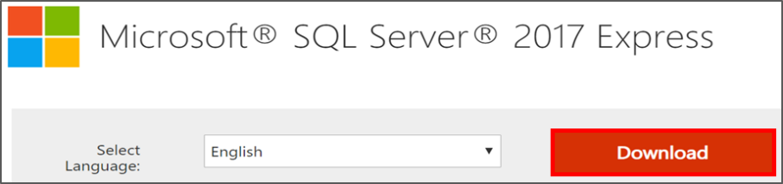

Select **‘Basic’** and then click **‘Accept’** to accept license terms.



Allow installation to proceed. Click ‘**Close’** to complete installation.



## Installing Angular 1.7.4

Users can download Angular 1.7.4 as a zip file using the following link: <https://code.angularjs.org/1.7.4/>

Open the link and select the .zip file for installing Angular 1.7.4.Extract the contents in the file.

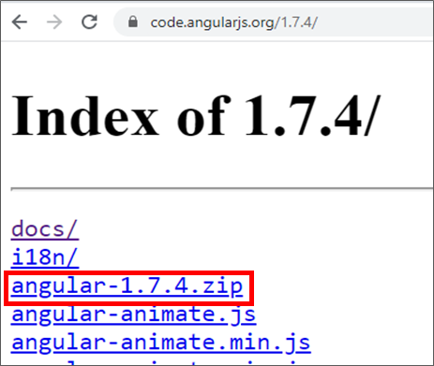

Next, open Command Window by selecting **‘Windows System’**.Right click on **‘Command Prompt,’** then select **‘More’** and click **‘Run as administrator.’**

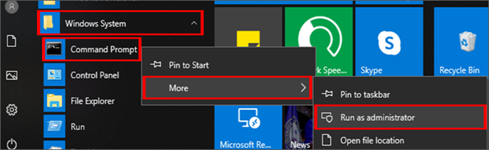

Type **'npm uninstall -g @angular/cli'** in Command Window and press **ENTER**. Next, type **'npm cache verify'** and press **ENTER** again.

Type **'npm install –g @angular/cli@1.7.4’** and press **ENTER** to install. Type **'ng -v'** and press **ENTER** to ensure successful installation.



## Adding PERCEPTRON-XFMS-XFMS Database using SQL File

The PERCEPTRON-XFMS Database SQL file is available inside the **Code.zip** folder, which can be downloaded from Mendeley (<https://data.mendeley.com/datasets/ssjxhyrtwc>) . After downloading, unzip the folder and navigate to the “DBSchema” subfolder to find the **PerceptronXfmsDBSchema.sql** file

Open Microsoft SQL Server Management Studio (SSMS). Click on “File”, “Open” and “File” to open ‘PerceptronXfmsDBSchema.sql” file in SSM and click **“Execute”** in toolbar.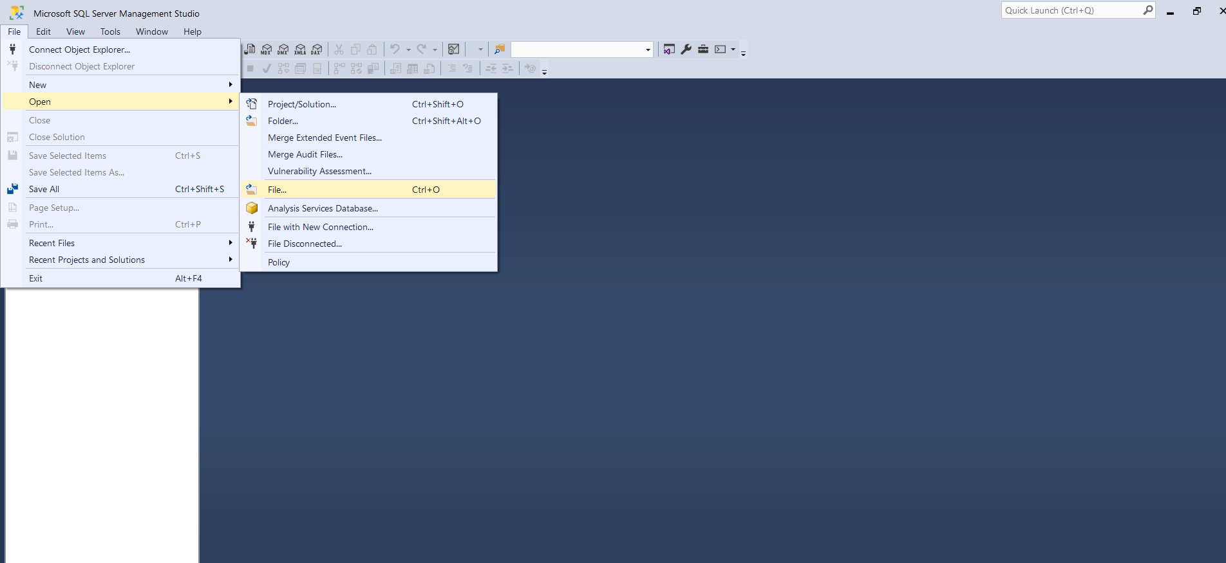

Upon successful execution, “PerceptronXfmsDatabase” will appear in Databases panel on left.

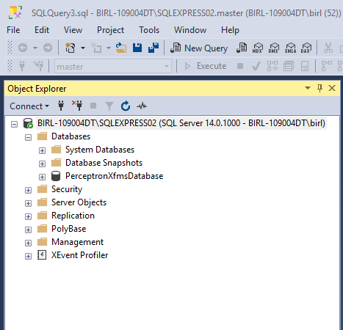

## Download MATLAB

Users can download MATLAB 2021b from the following link: <https://www.mathworks.com/products/new_products/release2021b.html>. Select “Download now” and sign in using your MathWorks account. Locate **matlab_R2021b_win64.exe** in your downloads folder, double double-click to run it. Continue through the prompts for Installation location and License. During the Select Products step, ensure that the following essential toolboxes required for PERCEPTRON-XFMS are selected: **Curve Fitting Toolbox**, **Bioinformatics Toolbox**, **Statistics and Machine Learning Toolbox**, **Image Acquisition Toolbox**, and **Image Processing Toolbox**.

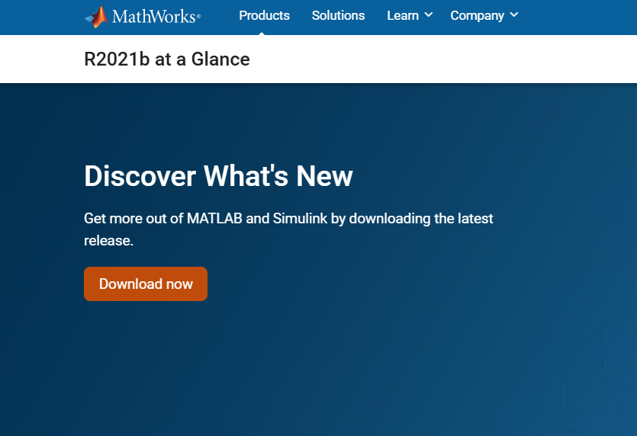

After successful installation and activation of MATLAB, ensure that MATLAB has COM support.

Run MATLAB as administrator and type **‘regmatlabserver’** in console.

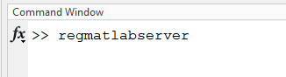

OR

Open Command Prompt as an administrator and navigate to MATLAB installation folder ( **cd ‘C:\Program Files\MATLAB\2021b\bin\win64’**) and run the following command ‘ **matlab /regserver’**

This registers MATLAB as a COM server

## Download R

Users can download R 4.2.2, by following the link: <https://cran.r-project.org/bin/windows/base/old/4.2.2/>.

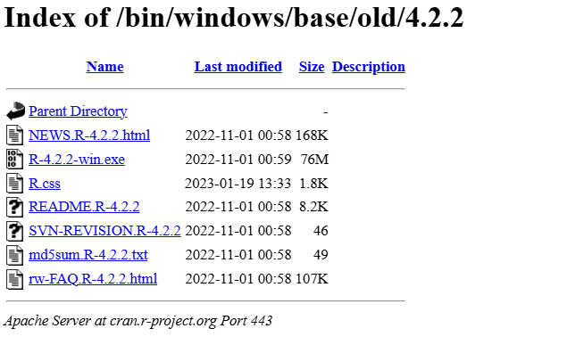

Next, install the setup downloaded.

Look for the R Installation in ‘**C:\Program Files**’ and copy the path ‘**C:\Program Files\R\R-4.2.2\bin’**.

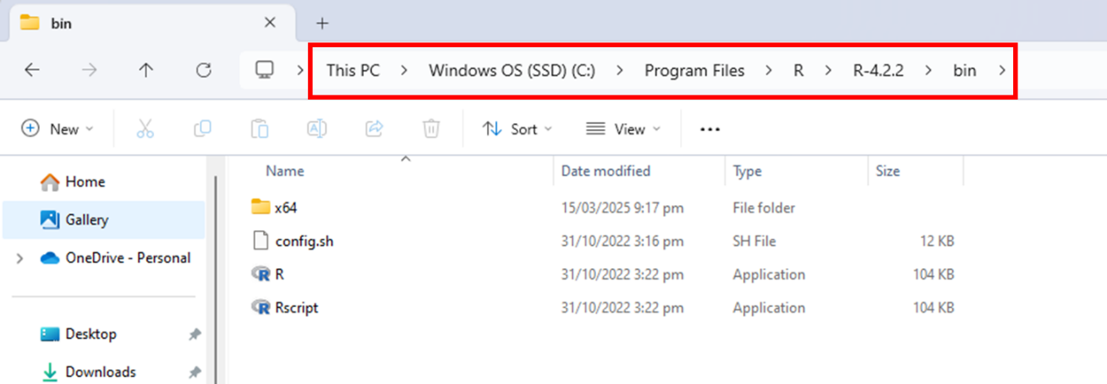

Make sure to set R path in ‘**Environment Variables**’

Open **System Environment Variables**

* Press Win + R, type **sysdm.cpl**, and hit Enter.
* Go to the **Advanced tab → Click Environment Variables**.

Edit the Path Variable

* Under **System Variables**, find Path, select it, and click **Edit**.
* Click **New**, then add the copied path ‘**C:\Program Files\R\R-4.2.2\bin’**. Click **OK** to save.

Open **R** and type the following commands to install the required libraries;

1. *install.packages("readMzXmlData")*
2. *install.packages("R.matlab")*
3. *install.packages("jsonlite")*

## Download Frustratometer

Users can download Frustratometer directly from the GitHub repository (<https://github.com/proteinphysiologylab/frustratometeR> ).Frustratometer is only for UBUNTU so, inorder to install it in windows users must download windows subsystem for linux (**wsl**).

Check if your system has wsl, if not then, open **cmd** as an administrator and type ‘**wsl --install Ubuntu**”

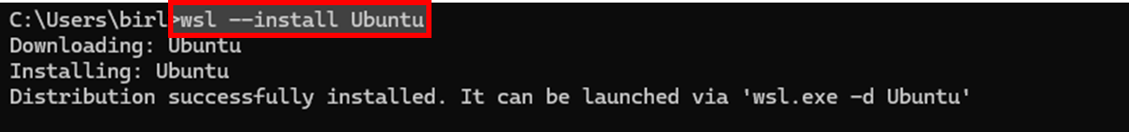

Type ‘**wsl’** and enter desired user name and password

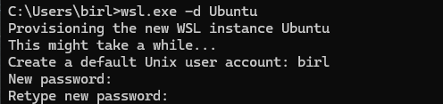

Check by typing if ‘wsl’ is installed

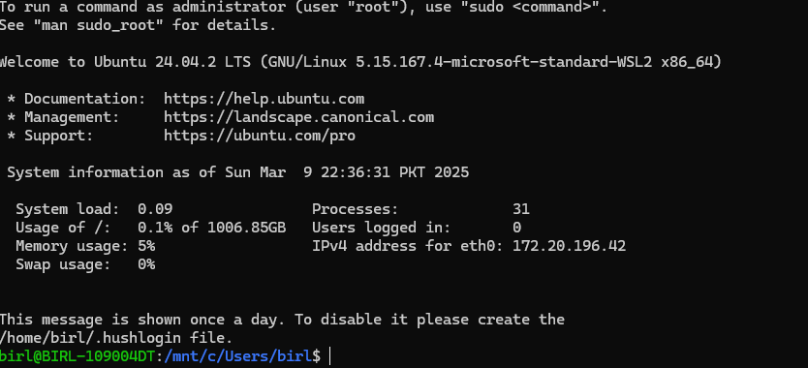

Install R in the ubuntu environment by typing **‘sudo apt update && sudo apt upgrade -y’** followed by **‘sudo apt install r-base -y’**

Confirm the installation by typing ‘**R –version’** in cmd

Once confirmed open R by typing ‘**R**” in cmd and download the libraries by typing following commands;

**install.packages(c("usethis ", " usethis "))**

**invisible(lapply(c("usethis", "devtools"), library, character.only = TRUE))**

**devtools::install_github("proteinphysiologylab/frustratometeR")**

For detailed instructions please follow the guidelines mentioned on the FrustratometeR page (<https://github.com/proteinphysiologylab/frustratometeR>). Make sure to install and check all the dependencies mentioned in the below figure. These packages must be installed in your Ubuntu environment.

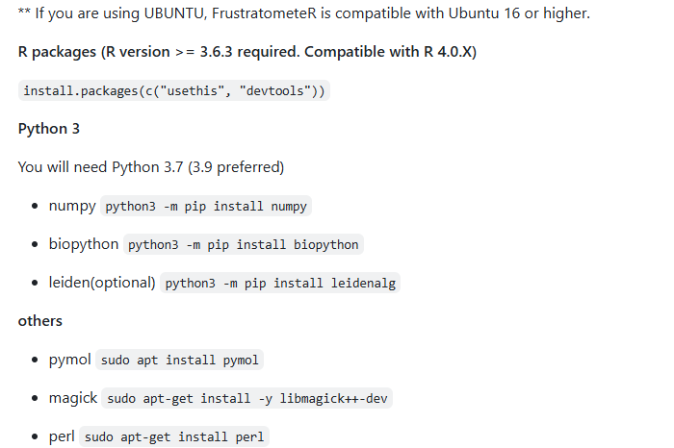

## Bridge2 Environment

Users first need to remove the python3env folder in the Bridge2 repository at location **\*\PERCEPTRONXFMS\ToolBox\Bridge2\_python3env.**  Make sure you have Python 3.9 or 3.10 installed on your local computer.

Open ‘**cmd**’ and change the directory to the Bridge2 folder by typing the following command:

**“ cd *\PERCEPTRONXFMS\ToolBox\Bridge2”**

Type “ **bridge2.bat**”

This will create a Python virtual environment containing all the necessary packages. You can start Bridge2 by typing “**python bridge2.py**” in the cmd.

If you encounter any issues with Python package installation, try removing the **python3env** folder and reinstalling the virtual environment. Additionally, ensure that the required library versions are compatible with the Bridge2 code. Table listing the compatible library versions has been provided for reference. If errors persist, check the library versions or refer to the official instructions at <https://github.com/maltesie/bridge2>.

Table - List of Python Packages and versions

|  |  |
| --- | --- |
| **Package** | **Version** |
| biopython | 1.85 |
| colorama | 0.4.6 |
| contourpy | 1.3.0 |
| cycler | 0.12.1 |
| et-xmlfile | 2.0.0 |
| fasteners | 0.19 |
| fonttools | 4.56.0 |
| GridDataFormats | 1.0.2 |
| gsd | 3.4.2 |
| importlib-resources | 6.5.2 |
| joblib | 1.4.2 |
| kiwisolver | 1.4.7 |
| matplotlib | 3.9.4 |
| MDAnalysis | 2.4.2 |
| mmtf-python | 1.1.3 |
| mrcfile | 1.5.4 |
| msgpack | 1.1.0 |
| networkx | 3.2.1 |
| numpy | 1.24.1 |
| openpyxl | 3.0.10 |
| packaging | 24.2 |
| pandas | 1.5.3 |
| pillow | 11.1.0 |
| pip | 20.2.3 |
| pyparsing | 3.2.1 |
| PySide2 | 5.15.2.1 |
| python-dateutil | 2.9.0.post0 |
| pytz | 2025.1 |
| scipy | 1.13.1 |
| setuptools | 49.2.1 |
| shiboken2 | 5.15.2.1 |
| six | 1.17.0 |
| threadpoolctl | 3.6.0 |
| tqdm | 4.67.1 |
| wheel | 0.45.1 |
| zipp | 3.21.0 |

# Building PERCEPTRON-XFMS-XFMS for in-house Deployment

## Downloading PERCEPTRON-XFMS

Users can download complete Data and Code from Mendeley (<https://data.mendeley.com/datasets/ssjxhyrtwc>) Unzip the folders and place the contents of the “**Code”** and the complete “**Data”** folder in the same master folder (below figure) and name it ‘**PERCEPTRONXFMS**’

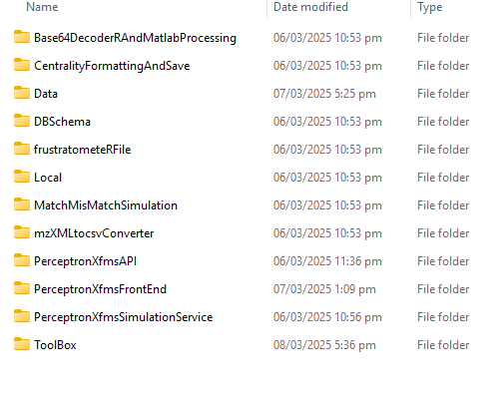

## PERCEPTRON-XFMS Calculation Pipeline

Open Main.m file from folder PERCEPTRONXFMS\ToolBox and change the following Input and Result folder paths.

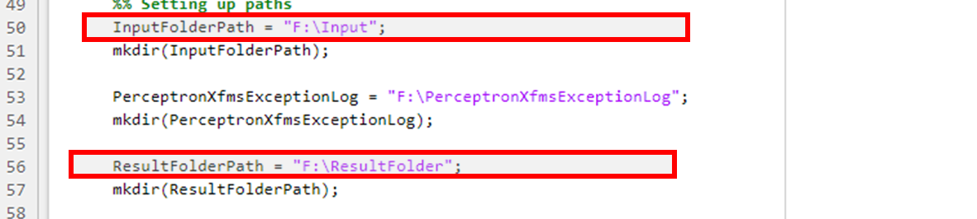

## PERCEPTRON-XFMS Application Programming Interface (API)

Open ‘PerceptronXfmsAPI.sln’ from the folder PERCEPTRONXFMS \PerceptronXfmsAPI in visual studio.In “Solution Explorer,” click on ‘**PerceptronXfmsAPI’.** Go to **‘App_Start’** and open **‘WebApiConfig.cs’**

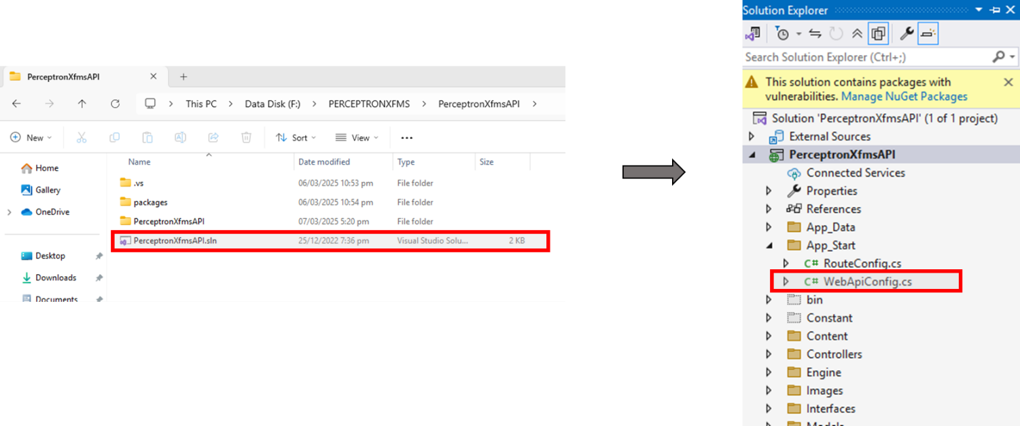

**(b)**

**(a)**

Open SQL Server Management Studio. Copy the given server name from SQL Server Pop Up.



In Visual Studio, open **‘Web.config’** from the Solution Explorer. Press **CTRL+F** to search item. Type server name, e.g. **‘CHIRAGH or BIRL-109004DT\SQLEXPRESS02’** and press **ENTER.** Replace themwith the server’s name copied above, i.e. **BIRL-109003-DT\SQLEXPRESS**.



**(b)**

**(a)**



Similarly, change the server’s name in Sqldatabase.cs (in Repository folder) as well. Replace the given name for all occurrences of **‘Server’** and **‘Data Source**’in *Sqldatabase.cs* with the server’s name from SQL Pop Up. In each case, add **‘@’** right before the inverted commas start for ‘Server’ and ‘Data Source’.

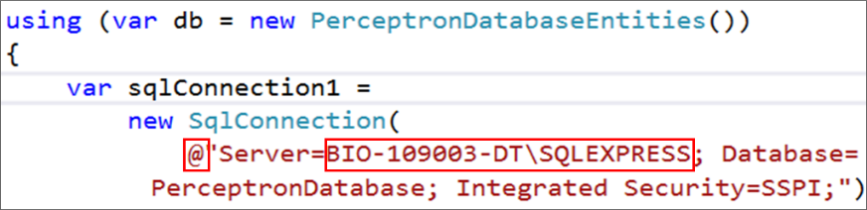

Change the Input folder as well as the default data folder in the **SearchController.cs** file. Replace the Input path with the one that you specified in **Main.m.**

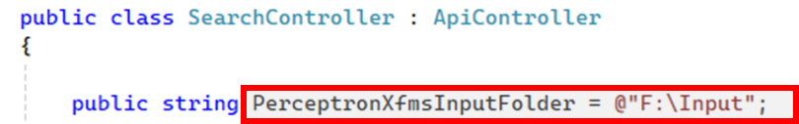

Replace the root path to the directory where your PERCEPTRON-XFMS whole project is present.

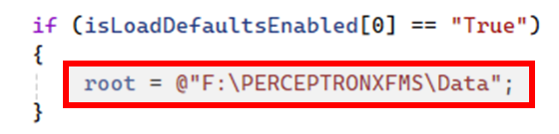

Run on **‘Google Chrome’** and save the URL (<https://localhost:44300/> )obtained.

**(a))**



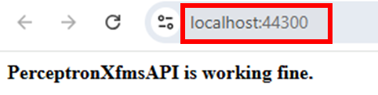

**(b))**

Message i.e., “PerceptronXfms API is working fine” ensures that PERCEPTRON-XFMS API has been successfully built and is running fine.

## PERCEPTRON-XFMS Front-End

Open Visual Studio Code. From **'File'** dropdown menu, select **'Open Folder'**.Select the folder **‘PerceptronXfmsFrontEnd’** from the path \PERCEPTRON-XFMS \.

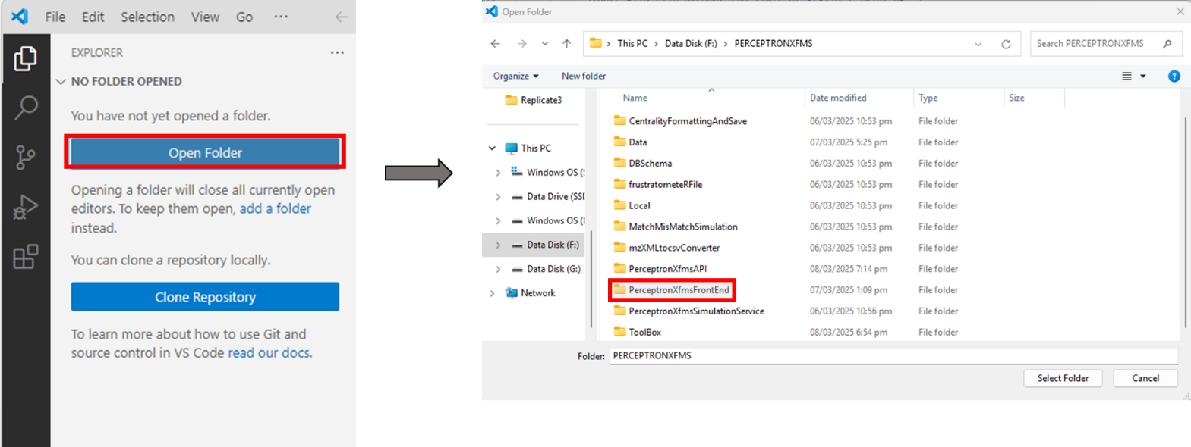

## Connecting PERCEPTRON-XFMS API to PERCEPTRON-XFMS Front-End

In Visual Studio Code, type **‘baseAPI’** in the search bar and select the one shown below. Replace the given URL with the one saved from Google Chrome (<https://localhost:44300/>).

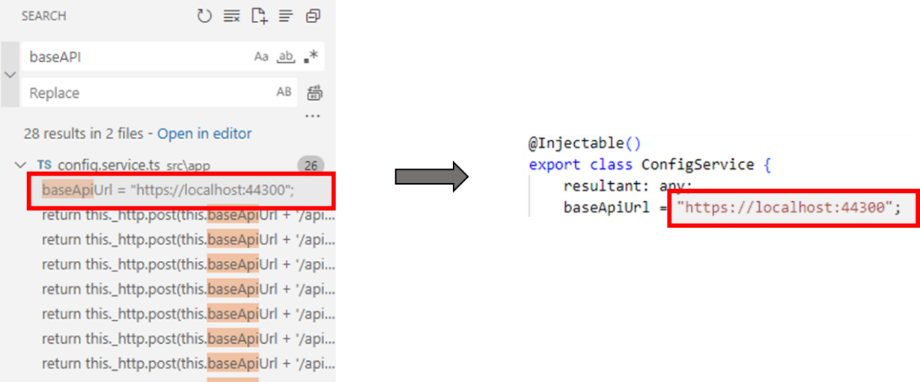

Open terminal, type **'ng serve'** and press **ENTER**. Open the link (<https://localhost:44300/>) provided in below Figure by pressing CTRL button + left mouse button.

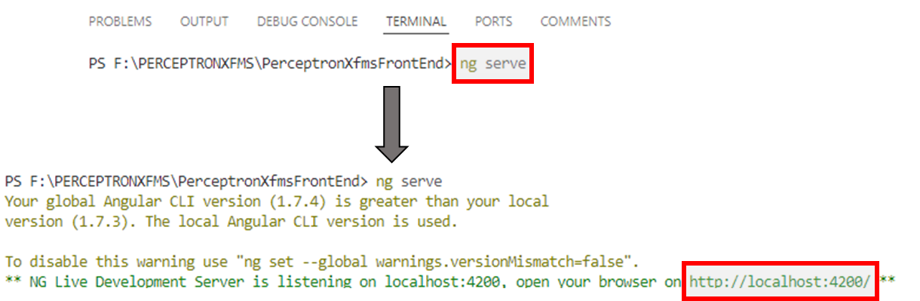

## PERCEPTRON-XFMS Simulation Service

Open SQL Server Management Studio. Copy the given server name from SQL Server Pop Up.



Open ‘**PerceptronXfmsSimulationService.sln’** from the folder PERCEPTRON-XFMS \ **PerceptronXfmsSimulationService** \ in visual studio.

In the Solution Explorer, select **‘App.config’**.

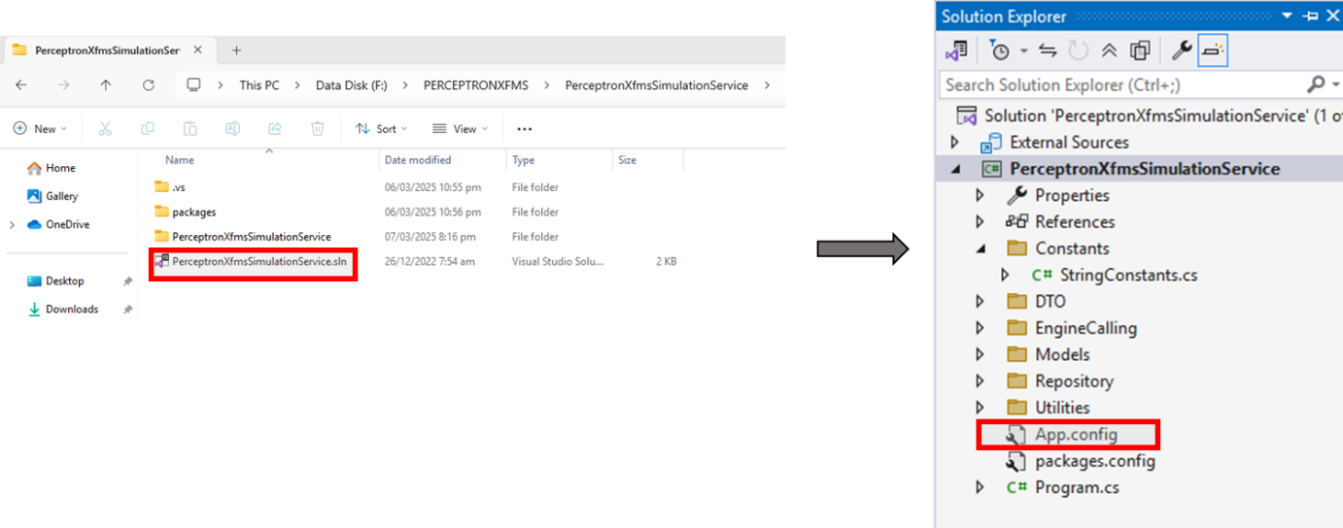

**(a)**

**(b)**

Press **CTRL+F** to search server name and Type **‘‘CHIRAGH or BIRL-109004DT\SQLEXPRESS02’** and press **ENTER.** Replace this name with the server name copied from SQL, e.g., **BIRL-109003-DT\SQLEXPRESS**. Replace the given name for all occurrences of **‘Data Source’** in App.config with the server name from SQL Pop Up.



Go to “Repository” under **PerceptronXfmsSimulationService** to open “SQLDatabase.cs”. Search for **‘CHIRAGH or BIRL-109004DT\SQLEXPRESS02’** and replace it with the Server name same as it was done for App.config. Also, add an ‘@’ before the inverted commas for Server start as shown in the figure below.

Go to “Constants” under **PerceptronXfmsSimulationService** to open “StringConstants.cs”. Replace the paths with your local paths. Please make sure that the **InputFolder** and **ResultFolderPath** are the same as specified in MATLAB Main.m file.

Send a XFMS Search Query on local host.

Open SQL Server Management Studio and click on **‘Connect’**



Select **‘New Query’** and type **‘SELECT * FROM PerceptronXfmsDatabase.dbo.SearchXfmsQuery’** in the window that appears. In SQL, click on **‘Execute’**.

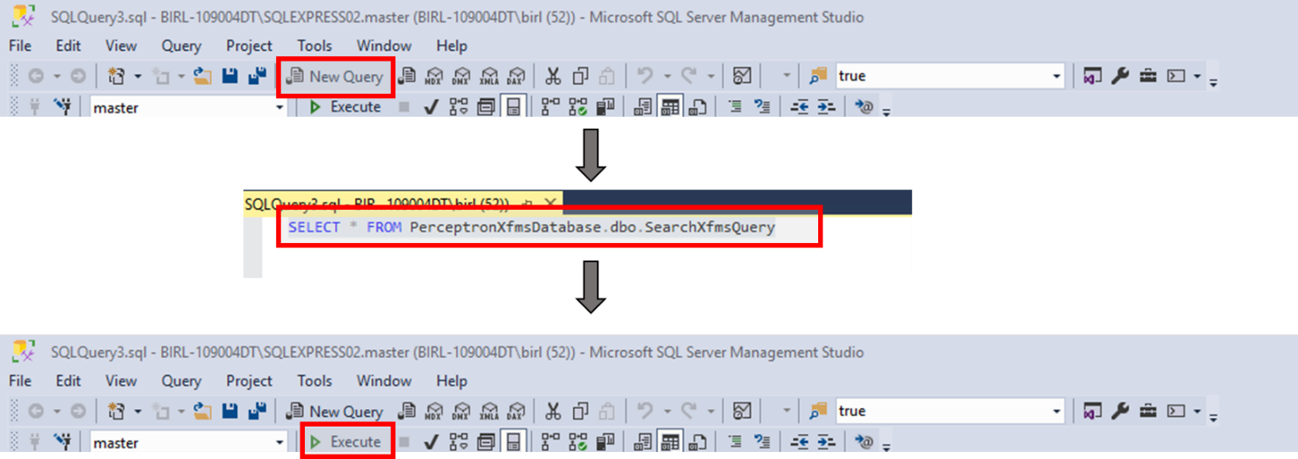



The query will show up in the Results Window.



In Visual Studio, open **‘PerceptronXfmsSimulationService.sln’**. Go to Solution Explorer and open **‘Program.cs’**. Click **‘Start’** to run it.

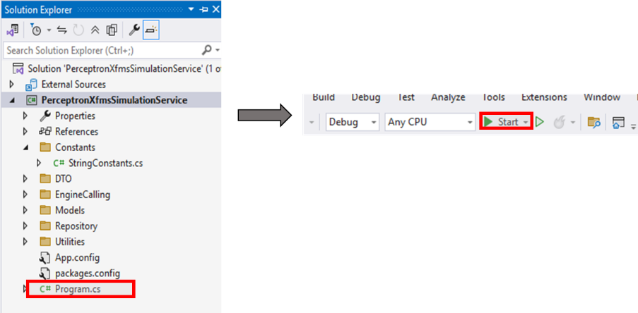

If breakpoints have been set, click **‘Continue’** to step over the breakpoints.

You can see the status of your query on the console and the SQL Server.

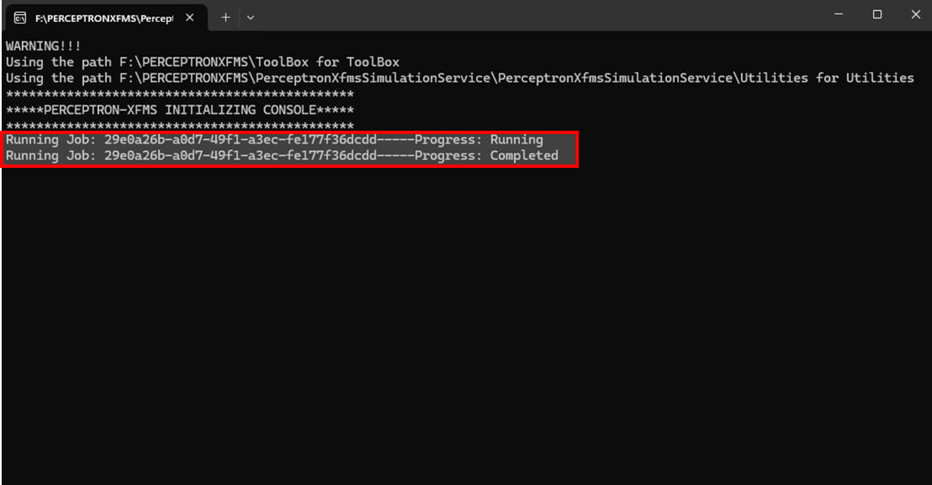



Results can be viewed in the ‘**Results’** folder specified.

